NEURAL COMPUTING AND DEEP LEARNING

LAB-1

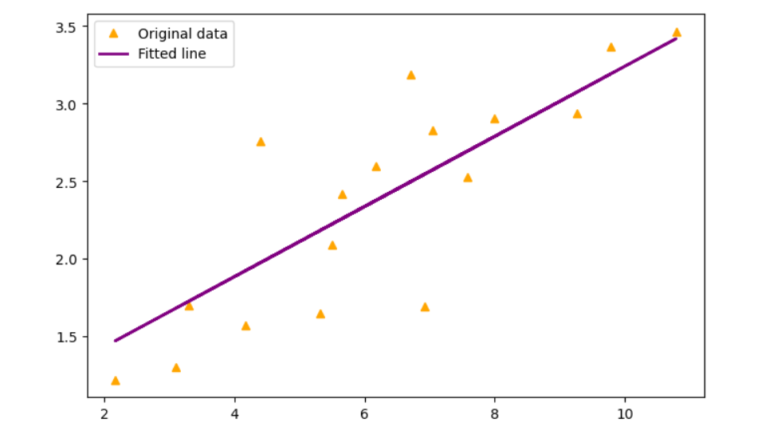

LAB-2

The Accuracy of the Model is 0.517

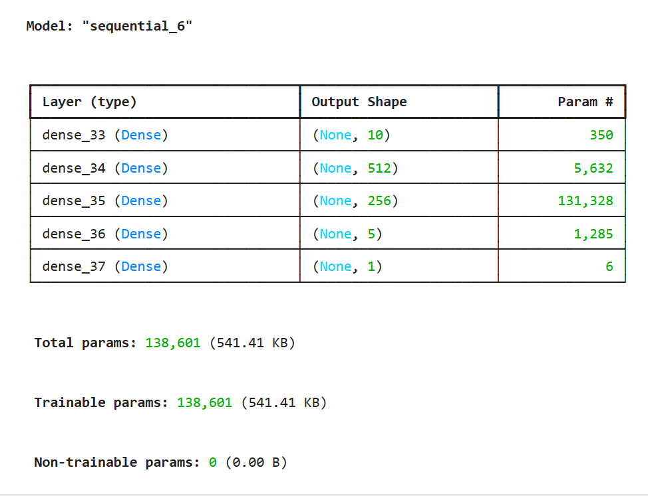

TASK:2

O1: 0.79
O2: 0.79

LAB-3

The Test Accuracy of the Model is 0.863

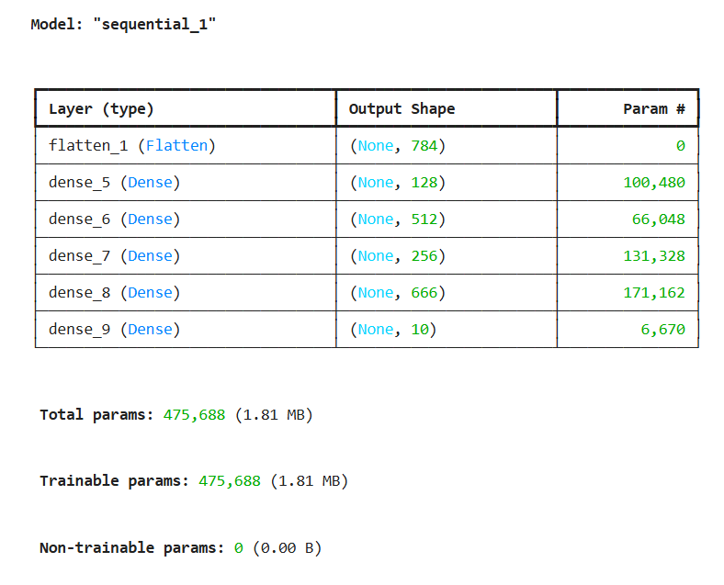

LAB-4

